**OverTheWire Bandit - Level 11 to Level 12 Writeup**

**Introduction**: This writeup documents my experience solving Levels 11 to 12 of the OverTheWire Bandit challenge, a CTF-style game focused on learning about security concepts.

**Author**: Misha Jain

**Date**: October 19, 2023

**Tools Used:**

Terminal (SSH client)

**Challenge Description:**

Level 11 to Level 12 of Bandit involves connecting to a remote server via SSH and finding a password stored in the file "data.txt," which contains base64 encoded data.

**Enumeration:**

For Level 11, we need to connect to the server using the credentials we obtained in Level 10. Our goal is to find a password stored in the "data.txt" file that has been ROT13 encoded.

**Exploitation - Level 11:**

To connect to the server for Level 11 using SSH, we use the provided credentials:

ssh bandit11@bandit.labs.overthewire.org -p 2220

Use the password obtained from Level 10, which is 6zPeziLdR2RKNdNYFNb6nVCKzphlXHBM to gain access.

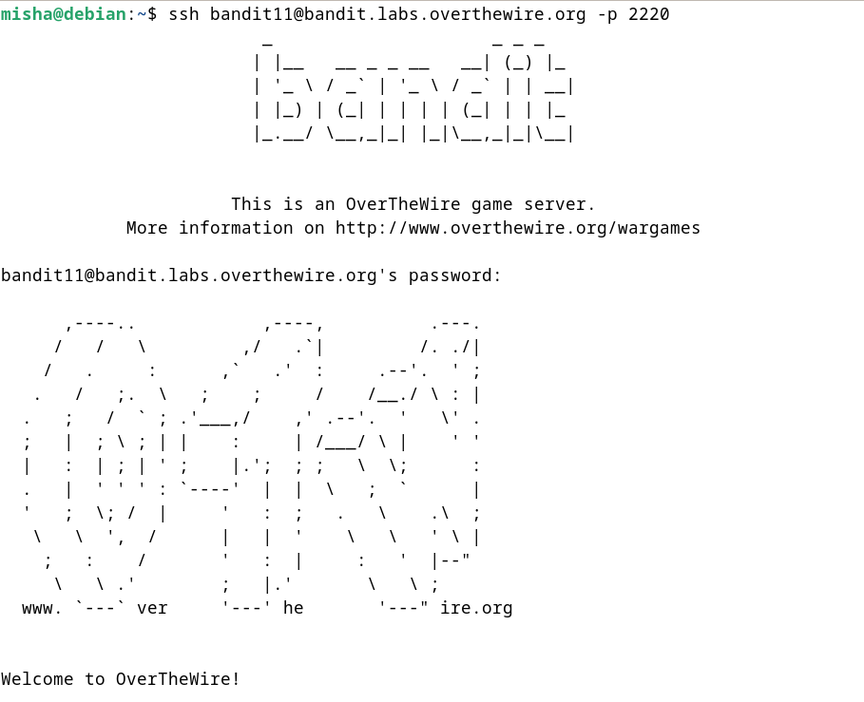

**Password Retrieval - Level 11:**

The password for Level 12 is stored in the file "data.txt," where all letters have been ROT13 encoded. To decode the text, we can use the tr command to perform the ROT13 operation.

cat data.txt | tr ‘A-Za-z’ ‘N-ZA-Mn-za-m’

The tr command will replace each letter with the letter that is 13 positions ahead in the alphabet.

These commands will display the Level 12 password.



**Password – Level 12:**

The password for Level 12 is: JVNBBFSmZwKKOP0XbFXOoW8chDz5yVRv

**Exploitation – Level 12:**

Now that we have the Level 12 password, we can connect to the server for Level 12 using SSH:

ssh bandit12@bandit.labs.overthewire.org -p 2220

Use the Level 12 password to gain access.

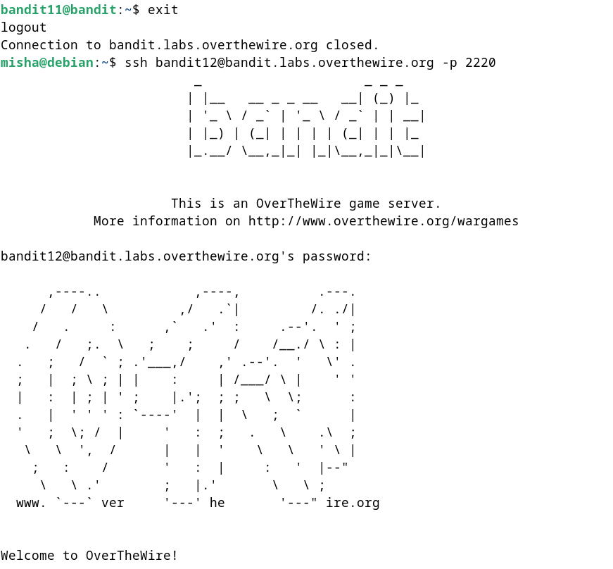

**Lessons Learned:** Level 11 introduced us to using the tr command for character replacement and performing ROT13 encoding/decoding. This level reinforced the use of text processing commands and data manipulation.\

**Conclusion:**

Levels 11 to 12 of the OverTheWire Bandit challenge continue to build on shell command knowledge while introducing new challenges involving text encoding and decoding. These levels are suitable for beginners to learn more about handling encoded data and file manipulation.